Gray: #EFEFEF --- background

Blue: #3454D1 --- buttons, headlines

Teal: #34D1BF -- text hover

Off-Black: #070707 -- sub heading, text

Pink: #FF3877 -- headlines, buttons

Fonts Family

Brusher

Glacial Indifference

League Spartan

Themes

Modern

Female-focused (but not overly female as we have male customers)

Bright, light colors

Large fonts

Heading 1 42px

Sub - 38px

I want a brand new top header area too--   
  
  
Maybe with a picture of me in the background? for the top part

**Section to include**

1. Resource and Guide

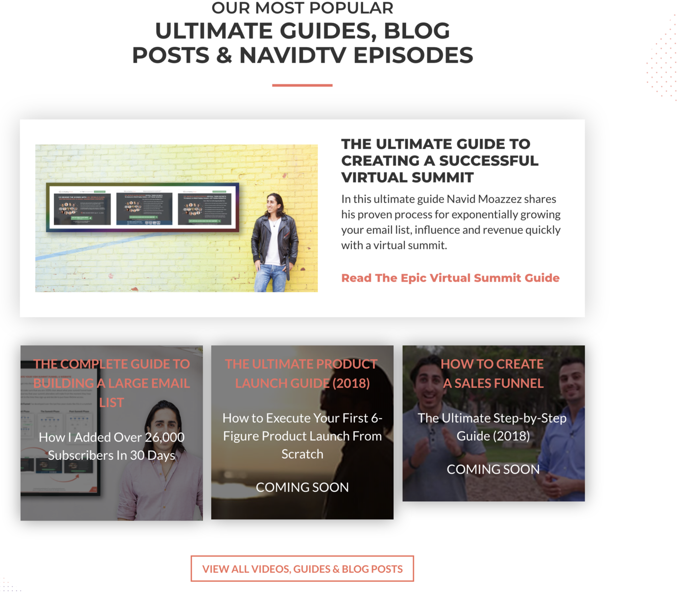

1. Testimonial

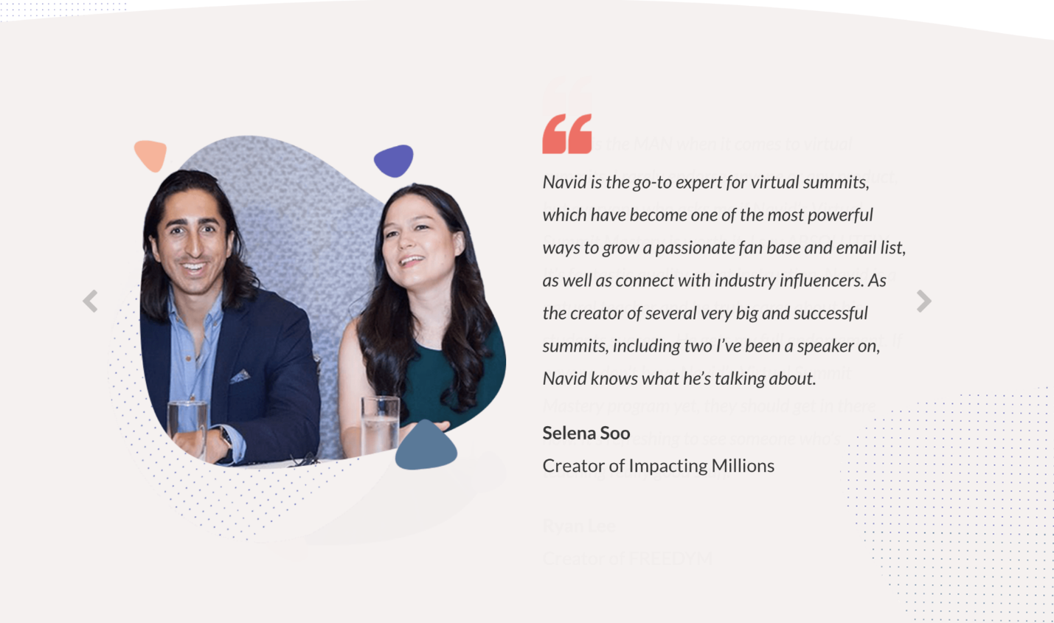

1. Random Links to Page overlay color:

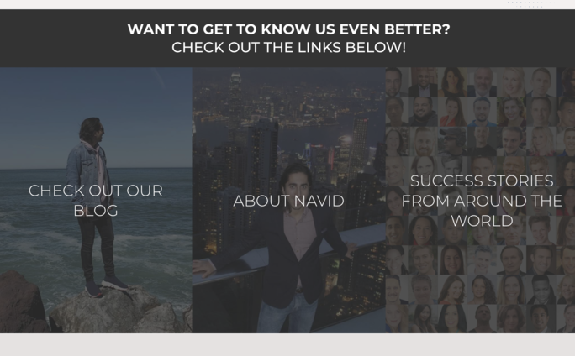

**Agency Sections**

1. Sales Letter

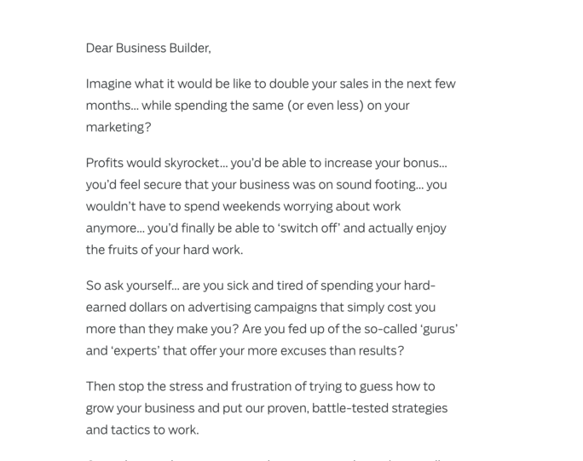

1. 